The Green and Yellow Line’s Battles

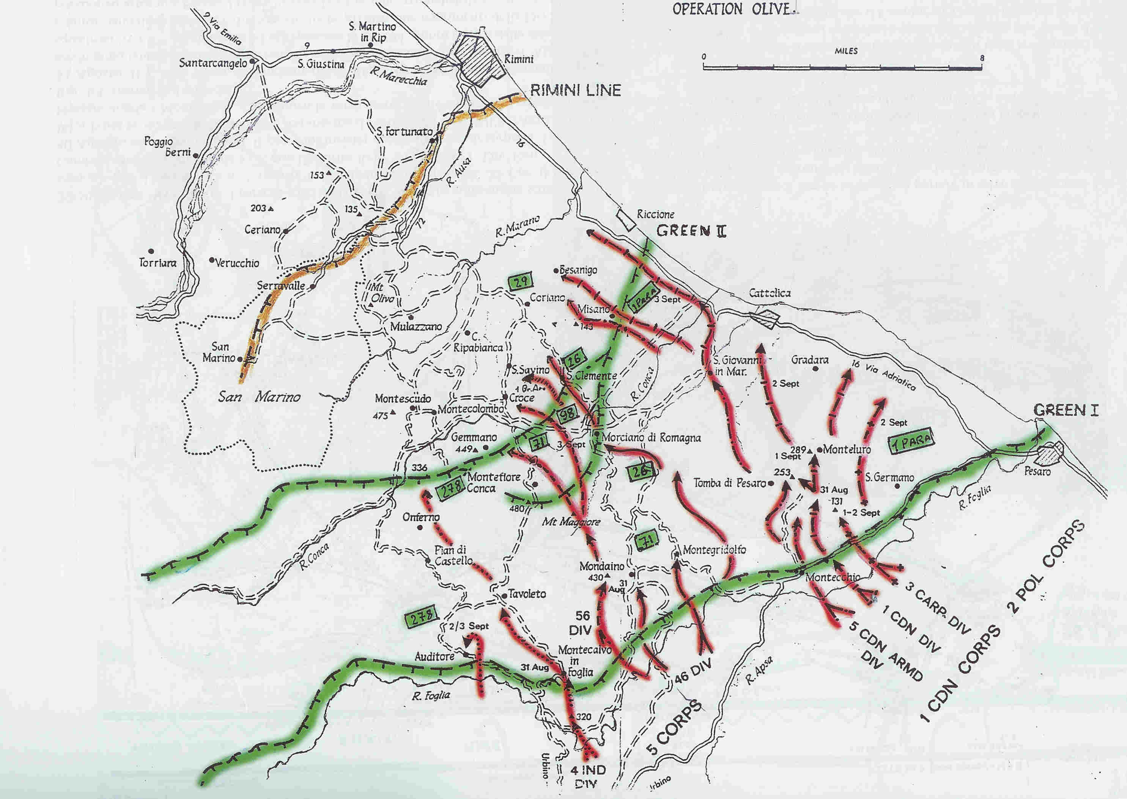

HISTORICAL STUDY for ASL’s SYSTEM
Used modules: Beyond Valor©, For King and Country©, and vary system’s maps

Notes Author

I think that Squad Leader has been one of mine first 15 games acquires to you in the far ones (sigh!!) years '80 and with my friend Enrico I have played nearly all the SL and COD scenarios. We tried also GI, but with insufficient satisfaction from part mine.
Between the other they were the times of gold of the historical simulation and tens of title them arrived in the Italian’s storees specialize (Internet to you were still “far”….), practically a true treasur for gets passionate to you like me. Natural I acquire many other games, on many other historical periods of equal or smaller difficulty and SL came set aside.
Also when I saw the publication of the advanced version of the game, ASL, I did not think to modernize my collection on such title it (today I possess approximately 300 board-wargames); me it seemed useless to lose time on a beautiful game but of great difficulty, enormous in its it nearly upgrades them but “the game of the life”, to which dedicating itself completely.
Then, some time makes, two facts “has waked up” the bear that slept in me .....;
- the publication of my book “The historical simulation”, where an optimal article of the friend Enrico Catanzaro trace the history and the development of game ASL;
- the passion that has swept up some associates of the A.S.G.S. (San Marino historical games association, in particular Enrico, Gabriele, Roberto, Danilo, Stefano, Fabrizio, Davide) that it has naturally take me!
In any way, from October 2006 I have decided to face of new ASL and hour in my collection many modules of the system are present; my passion for research purposes historical, at last, has pushed to me to plan some my modest scenarios for the system of more realistic more complex game but also on the tactical battles of the second world war.
Operation Olives: why this Campaign?
1- The Operation Olives is between the more important of the Campaign of Italy, since it caused to the crash of last the defense German before the Po Plain and the goal of Vienna.
2- I am born and alive to San Marino to 1 km. from the border of State with the Italy neighbor, practically in the zone that is the theatre of the battle for guado the Bonifizio (Scene OO #9).
3- I have read the more important books on the battle and have the honor to know the author between the most authoritative witnesses written on the Gotica Line, that is the Prof. Amedeo Montemaggi.
4- I have had the possibility to visit and to photograph many places of the battles, being rendered me account from the alive one of the type of land to represent.
5- I have had the fortune to collaborate with Dr. Cesaretti Daniele, expert of in its turn collaborating Gotica and of the Prof. Montemaggi. Thanks to the search of the Professor and the initiatives of Dr. Cesaretti, in 2008 will be commemorated, to Saint Marino, the episode that protagonist saw the soldier Gurka Sher Bahadur Thapa who earned the Victoria Cross on the hill Monte Pulito (Scenarios OO #13-14).
At last, I have had the fortune to be associate of the A.S.G.S., association that by now counts a group of forty of associates between which approximately 10 it gets passionate you of system ASL!
He was natural to try to recreate such battles thanks to a game system as ASL!
The Scenarios
Many, between the players who love ASL, will have tried to plan personal perhaps scenes and the notes that follow will appear useless, but I have intentional however to add them, in order to make to better understand the “philosophy” of the scenes that compose Operation Olives.
ASL has a precise scale of game: 1 turn = 2 minutes, 1 square = 5/10 men, 1 hexagon = 40 m from side to side, single leaders, wagons, guns, etc It is to the base of a any plan of scene on the system.
The battles of II the World war were often ferocious, long entire days if not weeks; a absolutely not recreated time with the own scale of ASL game. Also between by now the 4000 scenarios it publishes to you, those definable ones as “long” they introduce to the maximum 10/12 turns of game, equivalents not more than 20/30 minutes than real crash.
When I have begun the study of the battles that make part of this historical module, they are endured to me rendered account “of the problem”; many of they lasted more days and more nights. It was dealt, therefore, “to under investigation pick” a specific and representative event of the battle; to characterize, then, every battle with an episode or the particular land presence and/or units.
The same one, then, with regard to the effectively present units in the battle; also the difficultly deepened text more lists in the detail the units that fought, to level of scale always represented from ASL (squares, platoons, companies, squadrons wagons, etc). It was dealt in this case, to insert “elements” of major unit in the just amount and quality.
This “philosophy” is characteristic of all module OO. Naturally the games of playtest have been fundamental for the modifications to all the historical study.

Miscellaneous
Sherman and / or Churchill;
The Sherman tank was the most popular among the units of the British Army. Indeed it all equipped armored units, while Churchill was used to support infantry and special tasks in which “local bridge”. My sources on battles recreated in this module does not always allow you to understand which of the two models were present. Where sources not cited armored units so precise, I tried Churchill, as I used the Sherman armored unit quoted accurately.
OBA, bombing;
The artillery was one of the winners of 8a Army . I do not use more OBA, a rule always not loved by players. I liked a rule controls moral established as a result of Bombing, with relative placement of shelholes, so I used that. The result is immediate and makes good the effects of this weapon on German troops on the ground.
For other considerations, see also SSR.

The Montecieco charge

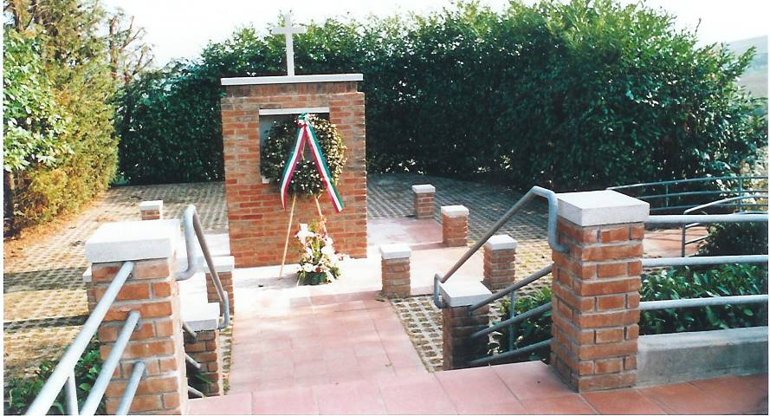
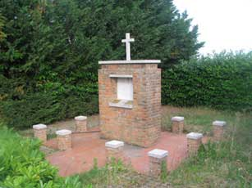
The monument

Montecieco is a small group of houses midway between Rimini and Verucchio, which was not even nominated in the old cards military Italian 2nd World War (in its place was the word "schools" or "Osteria").
In stories military English and German, on the other hand, has a very important place; known as the Second Balaclava or Balaclava Armor, recovering the memory of the famous and reckless, almost suicidal, Office of the light brigade (or seventeenth century) in the valley of Balaclava in the Crimean War of 1854. The ridge of Montecieco had great strategic importance at the center of Yellow Line, because, after the Canadian breakthrough, September 18, 1944, at the Battle of San Fortunato (as it chronicles the Allied reminiscent of the hill Covignano, beaten by 360mila bombs and grenades like no other place of the 2nd World War, except for the French Caen), now the British, to Montecieco, could split in two the German front, bring to Sant'Ermete and Santarcangelo and go behind, cutting them retreat, the German defenders of Rimini.
On the afternoon of September 19, the Regiment of the Queen's Bays, the pride of the 1st Division British warship, had received the order to attack Montecieco, senonchè charging tanks had to be postponed to the next morning because dell'ingorgo vehicles on British Roveta narrow street (today via Montecieco).
In the night between 19 and 20, however, German on the front came from Santarcangelo a group fighting the 90th Division armored grenadier commanded by the legendary General Baade and the orders of Colonel Stollbrock, dispose its guns to destroy any striker.
When, at 10.50 am on 20 September, 27 tanks British left uncovered for progress towards Montecieco, in a few minutes 24 of them were destroyed, and only 3 were able to return safely to their lines.

___________________________________________________________________________________________________

Designing scenarios on the historical map of Montecieco was a lot of study of the sources, search and maps of various surveys on the site of the battle.
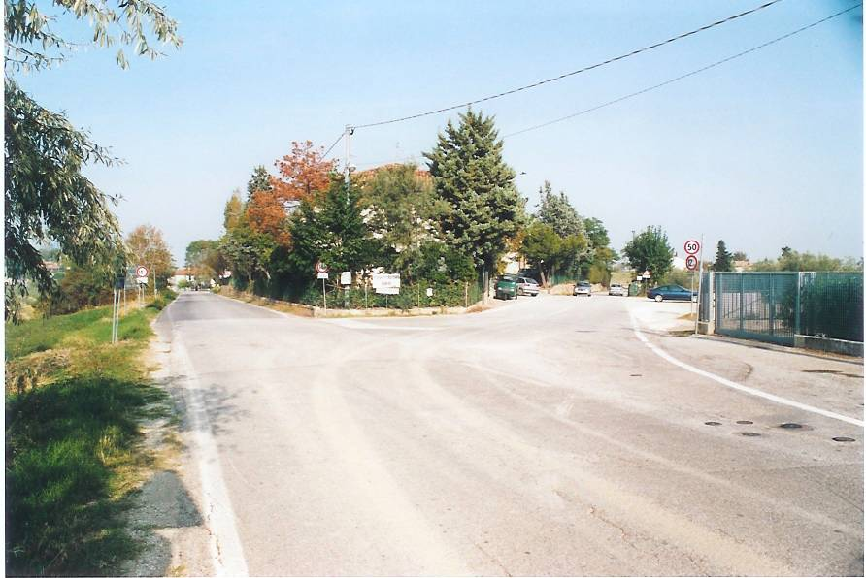
View Quota 153 on the high road
The work has allowed me to understand many of the actions described in the sources, in particular the works of Prof.. Montemaggi, from technical point of view. Let me explain.
Whatever the source, although it is authoritative, can describe an historic event thanks to the testimony of participants and / or reports of various kinds, from images writings, etc.. But hardly can appreciate fully the conduct "practical" of a battle. To design scenarios on Montecieco with friends who have worked, I played in practice a sort of "experimental archeology", which is to try literally if certain actions were carried out, if they can, if they correspond to the notes available.
The first thing that I realized, for example, by visiting the battlefield, was the limited view that the British commanders of Sherman could have the crossroad of Montecieco (see the "stone" in hex 2409). Right to Share 153, along the "high road", this view is not more than 300 meters.; Left even worse, as the hill of Cà Cima blocks the line of sight shortly after 50 meters. Approximately. Faced, on the contrary, you have visibility to less than 1 km. Toward the gently sloping hills to the north.
The same levels generated from these hills and fields of wheat, olive trees, vineyards, are so "sweet", in fact, that the whole area is a large amphitheater, with sight lines that extend from the junction unhindered north apart some wood shed.
From these considerations, what follows?
Meanwhile, that "transfer" levels on the actual system of ASL is not easy, given the visual field, the whole area is represented by a single layer (0), where major clashes occurred in this manner becomes possible for a German cannon, hidden everywhere in level 0 can see the "high road".
The hill to the left of the crossroads at +20 door to St. Paul in this area seems to be placed some guns, including a 88; on map it is not in extended, and the position, probably in the north-east of Cà Tentoni, it is not represented, even for the sake of size

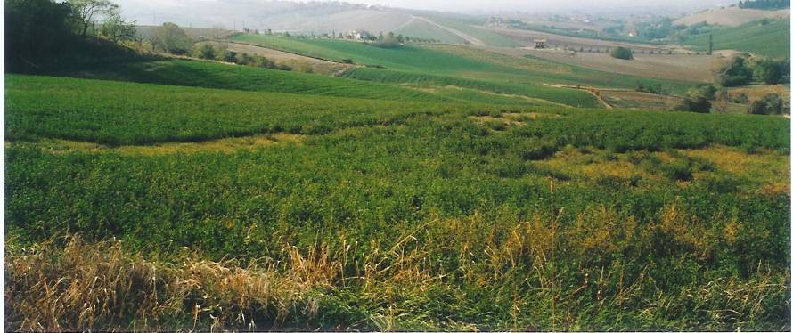
North view from the crossroads

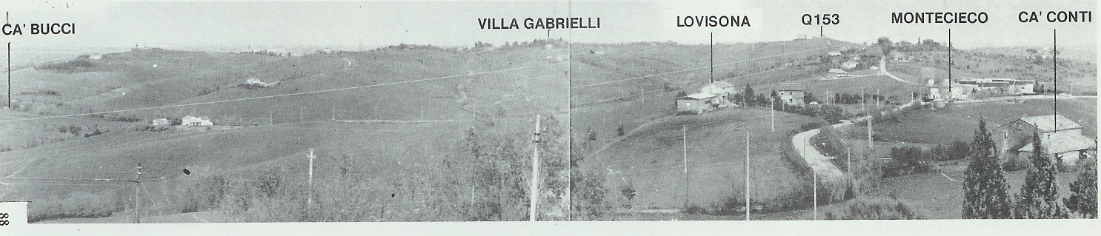

Image taken from the book Rimini-San Marino'44 A. Montemaggi;
The view from above is Cà accounts, and then at 2 Map.

La battaglia di Monte Pulito
18 Settembre 1944 - San Marino

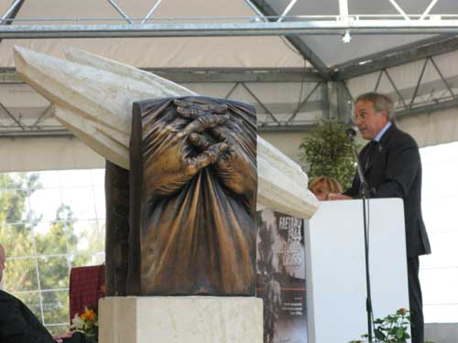
The monument in Faetano

The Second World War is remembered mainly for large battles such as Stalingrad, Kharkov, Kursk, Midway, Normandy, and so on.
But alongside them are remembered by a series of smaller battles, "or secondary, you want to use a small n. soldiers, either for the brevity of the clash itself.
This list can also enter the battle of Monte Pulito, Faetano of San Marino.
On 18 September 1944, in fact, be fought fiercely in this area, for the achievement of a hill almost insignificant. The department used was 1 / 9 GURKHA Rifle Division's 4th Indiana;
among his men Sher Bahadur Thapa, who with his acts of heroism posthumously earned the Victoria Cross, the highest British military award.
Scenario No. 12 lets you recreate this episode.
On 20 September 2008, at the end of a major commemorative event, was discovered a monument in memory of that gesture.

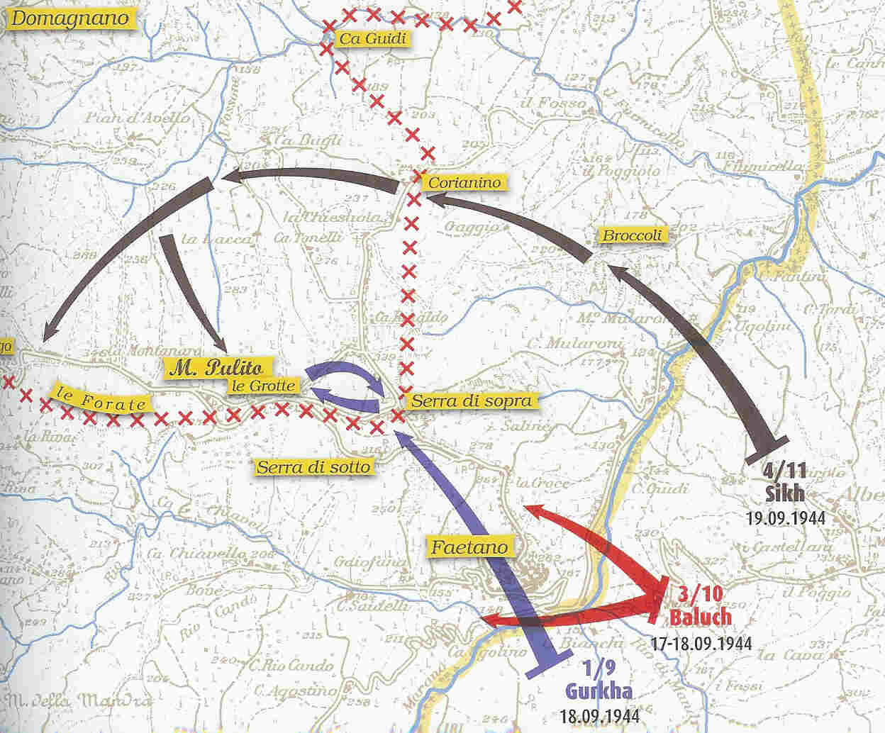

Battle map

The Romagna as battlefield
"The rains in September and October 1944 were among the most abundant in recent years," said the Gen. Alexander, who added that they helped very withdrawn the German, a judgment that was also expressed by several German commanders.
The 8 ° Army, expert of the war between the desert and the mountains, he found himself in difficulties facing a new experience violator that the hopes which until then commands from allies, who thought the Po Valley was a suitable ground for episodes of armor. Indeed Romagna is a plain, but covered by a series of rivers with high channeled sand embankments, built to imprison water streams inflated for rain or snow melted. The ground is soft, dusty or muddy depending on the weather. By destroying bridges, these rivers were transformed into many obstacles and became anti well as a barrier to fanterie when gonfiavano. The only routes with massicciata solid road ran along the sea, while the side ran along the edges, which can be easily blocked, while roads leading to the hills and mountains were often non-existent.
When raining, and then, the ground is transformed into a terrible mud.
In addition to this the many small villages and the various farms that punteggiavano the plain Romagna provided to German soldiers excellent cornerstones and viewpoints. The cottages gave the Germans the opportunity to develop and implement the so-called defense in depth. The Allies had snidare and win every farmhouse, because often demolirlo meant to create a better defense among the ruins.
The visibility was often limited by orchards, from the olive trees, and vineyards. Often, having broken through two or three rows a tank was immobilized by viluppo shoot and iron wires blocking the tracks. Among a row and the other Germans appostavano shooters chosen, machine guns, panzerfaust, etc..
A real tragedy for the Allies advanced

Gli Scenari
Linea Verde - 2
- Coriano
- San Savino
- Croce
- Gemmano
- II San Savino
- Gemmano – linee fluide
- Gemmano – la Cassino dell’Adriatico
- II Coriano

Linea Gialla
- Rovereta – il guado “Bonifazio”
- Montelupo
- Monte Pulito
- Monte Pulito – Victoria Cross
- Torraccia di Galazzano
- San Fortunato
- Montecieco: Il contrattacco tedesco
- Montecieco: Cà Cantoni
- Montecieco – La carica dei Queen’s Bays
- Montecieco – Uomini contro carri armati!
- Montecieco – L’attacco da Cà Battaglini (what if)

Ricerca storica, progettazione iniziale:
Giancarlo Ceccoli

Playtest:
A.S.G.S.

San Marino, Agosto 2007

Resource:

Soldatini on Line: http://www.soldatinionline.it/

Gothic Line: http://www.gothicline.org/offensiva/offensiva.htm

La Battaglia d’Italia, W.G.F. Jackson, Edizioni Accademia, 1978

Offensiva della Linea Gotica, Amedeo Montemaggi, Arti Grafiche Della Balda—RSM, 1980

Rimini San Marino ‘44, Amedeo Montemaggi, Arti Grafiche Della Balda—RSM, 1983

LINEA GOTICA 1944. La battaglia di Rimini e lo sbarco in Grecia decisivi per l'Europa sud-orientale e il Mediterraneo, Amedeo Montemaggi, Museo dell’Aviazione, 2002

Linea Gotica ’44: scontro di civiltà, Amedeo Montemaggi, Museo dell’Aviazione, 2006

La campagna d’Italia, WAR SET, 2005

World war II Infantry Tactics, Stephen Bull, Osprey Elite, 2004

World war II Infantry Anti-Tank Tactics, Gordon L. Rottman, Osprey Elite, 2004

Le due battaglie di Savignano, Amedeo Montemaggi, Guaraldi, 2004

Quelli della Gotica, Andrea Santangelo, A.R.S.A., 2005

Faetano 1944 - Victoria Cross, AIEP, 2008

Operazione Olive Credits

Design: Giancarlo Ceccoli
Historical research: Giancarlo Ceccoli
Scenarios: Giancarlo Ceccoli, Enrico Granata, Gabriele Mazza.
Development e layout: Critical Hit
Coordination playtest: Giancarlo Ceccoli, CH
Playtest: Enrico Granata, Gabriele Mazza, Davide Magnani, Fabrizio Andreatini, Roberto Da Forno, Danilo Bacchini, Loriano Ramazzo.
Box:
Maps: Giancarlo Ceccoli (Monte Pulito, Monte Cieco, Torraccia), CH.

Acknowledgments:
I am really grateful to the members A.S.G.S. that contributed to the research and development of scenarios Operation Olive; without them this study would never have seen the light. In particular Enrico, Gabriele, Davide, Fabrizio, Maurizio, Giuseppe, Danilo, Roberto, etc.. who playtest on various scenarios and worked with research, notes, etc..

I thank Prof.. Amedeo Montemaggi for his work and for his valuable collaboration on some aspects of the campaign analyzed.
Fundamental collaboration with Dott. Daniele Cesaretti, passionate, and historical researcher finds war.
Thank you, finally, to my wife Joan and my daughter Julia. San Marino, 2007

For Historical Notes, you look:

http://www.gothicline.org/inglese/politica/politica.htm
http://www.gothicline.org/inglese/offensiva/offensiva.htm

I luoghi delle battaglie
2

San Fortunato Coriano
San Savino Croce

Montecieco Gemmano Quota 204

Benefizio

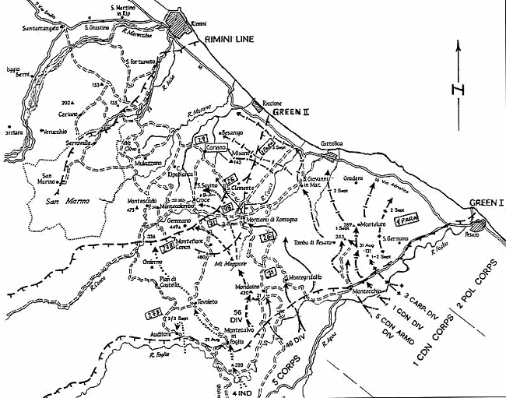

Montepulito Montelupo

Torraccia di Galazzano

